Home Work 2
5. The data set WeakInstrument contains 200 observations on 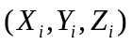 for the instrumental regression 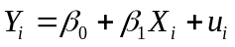
a. Construct 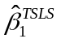, its standard error, and the usual 95% confidence interval for 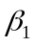 .

b. Compute the F-statistic for the regression of 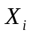 on 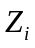. Is there evidence
of a “weak instrument” problem?

c. Compute a 95% confidence interval for , using the Anderson-Rubin
procedure. (To implement the procedure, assume that .)

d. Comment on the differences in the confidence intervals in (a) and (c).
Which is more reliable?

